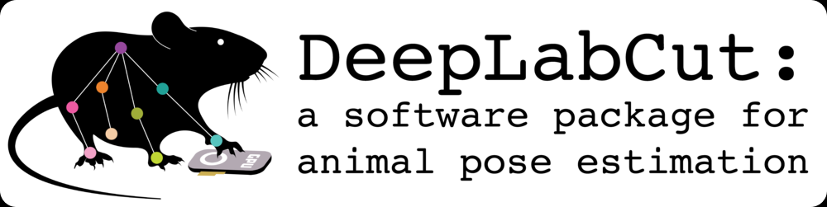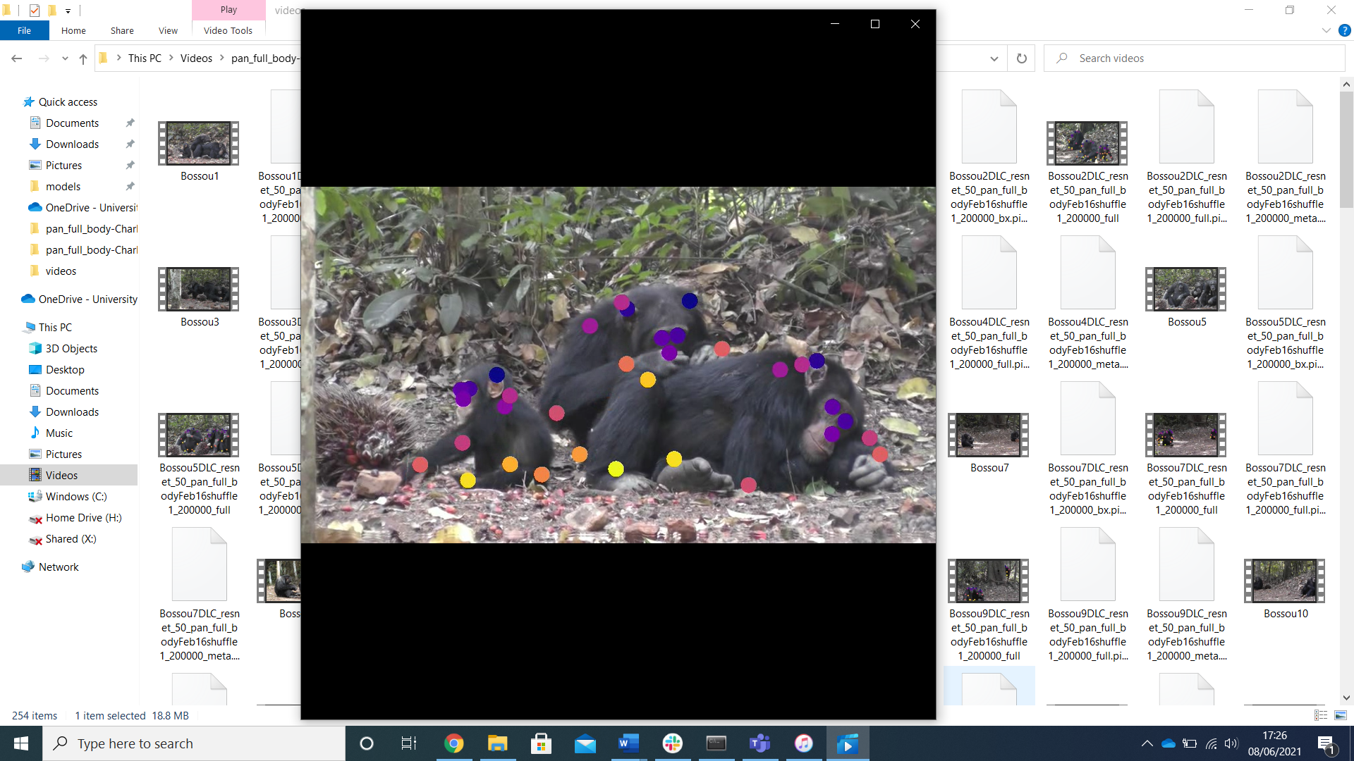

Charlotte Wiltshire  
June 2021

**How to mark frames for the ape full body model (Mac)**

Contents

Installing DeepLabCut (updated 03/08/21) 3

Opening DeepLabCut 5

Setting your files up 5

Loading the project into DeepLabCut 6

The labelling GUI explained: 8

Marking protocols and examples: 10

Filling in the Google Sheet: 11

Checking your marking 12

Sharing your labelled data with us 12

# Installing DeepLabCut (updated 03/08/21)

This step can be a little tricky but please don’t let it put you off! Installing DeepLabCut involves using python, and if you are not used to this it can be intimidating. Stick with it. Once it is downloaded, things get easier! This will walk you through how to download the CPU version of DeepLabCut. This version should load on virtually any computer, regardless of it’s computational power.

**Step 1: Installing Anaconda**

The first step is to instal python. The easiest way to do this is by using a programme called Anaconda. Anaconda basically downloads and installs a bunch of super helpful packages for you, making python easier to use.

<https://www.anaconda.com/products/individual#Downloads>

Use that link and download the one suitable for your computer. For Mac you want the “64-Bit Graphical Installer (440 MB)”

**(Step 1.2: Opening Python/Anaconda)**

Anaconda will download a few different programmes and ways to use DeepLabCut onto your computer. I find for DeepLabCut the easiest to use the terminal itself. Shut down all it opens when you download anaconda, it is way beyond what you need to use anaconda for. Instead, type “terminal” into your computer search bar. You should see this icon:

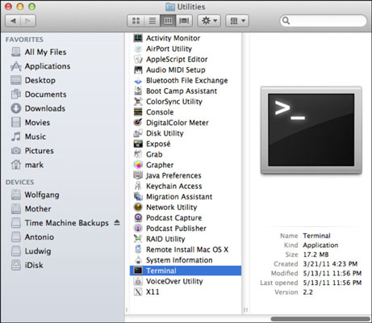

And this will open a screen something like this:

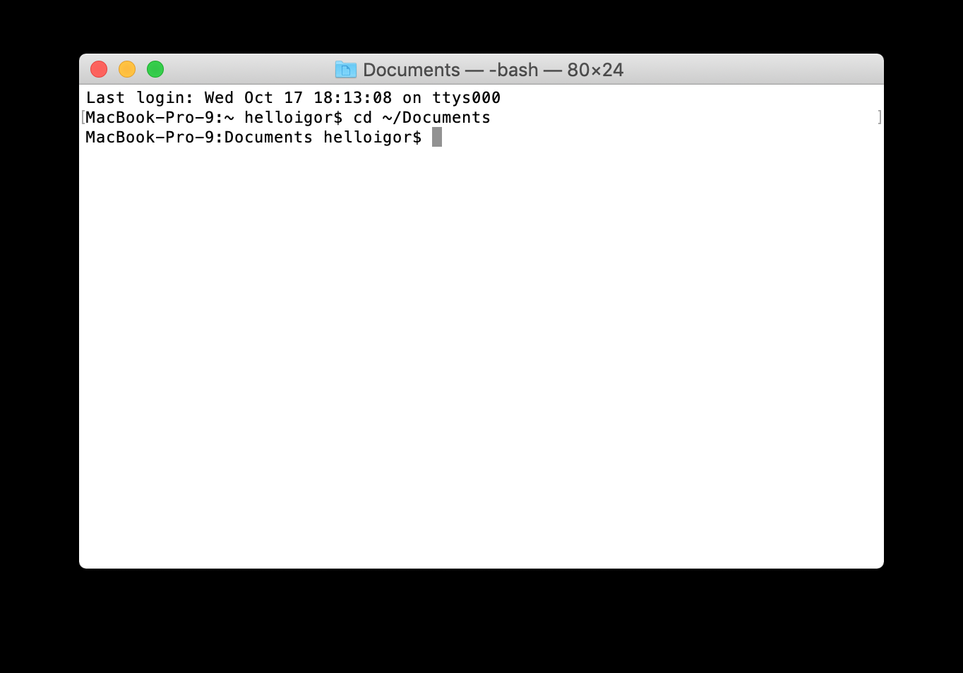

You need to check now that python is using the correct version. Mac will sometimes use an old version of python as default, to check this

Python--version

**Step 2: Setting up a DeepLabCut environment**

This step basically stops you from messing about with important things on your computer. When you set up an environment, it means anything you do stays within this environment, and you don’t accidentally end up messing with files you shouldn’t. You will need to download the DLC-CPU.yaml from DeepLabCut’s website. Download the file and put it on your desktop

<http://www.mackenziemathislab.org/deeplabcutblog/2021/6/30/tensorflow-2x-is-the-new-default-in-deeplabcut>

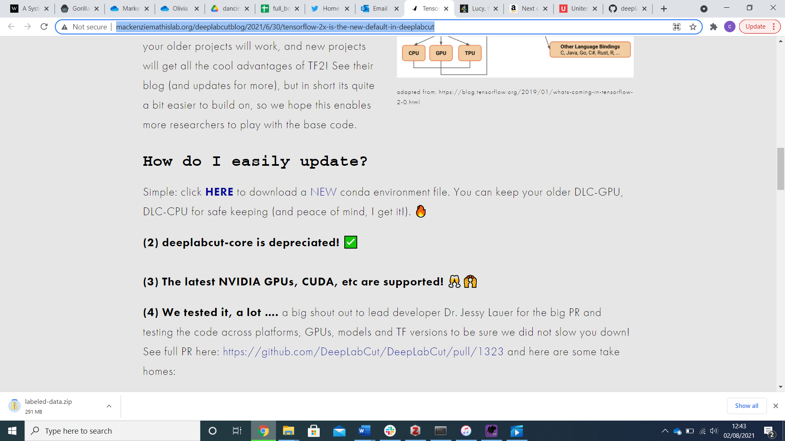

Now the file is on your desktop, you need to let anaconda know where to look for it. Change your working directioy.

cd “enter file path here”

Your file path is usually /Users/*your name on your computer*/Desktop

conda env create -f DEEPLABCUT.yaml

This will download deeplabcut!

**Step 3: Activate DeepLabCut environment**

You need to activate the environment. This means you are now working within it.

Conda activate DEEPLABCUT

You will know if this step has worked because the left-hand side of your anaconda will change to DLC-CPU.

**Step 5: Install python.app**

This allows DLC to open

conda install python.app

**Step 5: Loading pythonw**

pythonw

**Step 6: Opening DeepLabCut for the first time**

import deeplabcut

(be patient, this step can take a while! As long as the little white line is flashing it hasn’t frozen)

deeplabcut.launch_dlc()

The GUI will now open! Well done! 😊

# Opening DeepLabCut

Open terminal

Conda activate DEEPLABCUT

pythonw

import deeplabcut

deeplabcut.launch_dlc()

The GUI will now launch 😊

# Setting your files up

I will send you a file which contains all you need to load your project! Please download this folder and put it in the “videos” part of your computer.

If the file is zipped, please unzip it.   
Do not change the names of the folder or any files. If unzipping it changes the name (eg-adds a (1), please delete that so the name matches exactly what I sent over)

**Changing the config file**

Go into the folder and you will see a “config” file. Open it.

Within that there will be a line like this:

# Project path (change when moving around)

project_path: C:\Users\cw266\Videos\pan_full_body-Charlotte-2021-06-01

I need you to change that to the path on your computer!

You can right click the config file in the folder, click “get info” and see what is written under “where”

For a Mac, it should be :   
project_path: \Users\*your name on your mac*\Videos\pan_full_body-Charlotte-2021-06-01  
(Please note you will have a unique date, just look at the folder name and change this code accordingly)

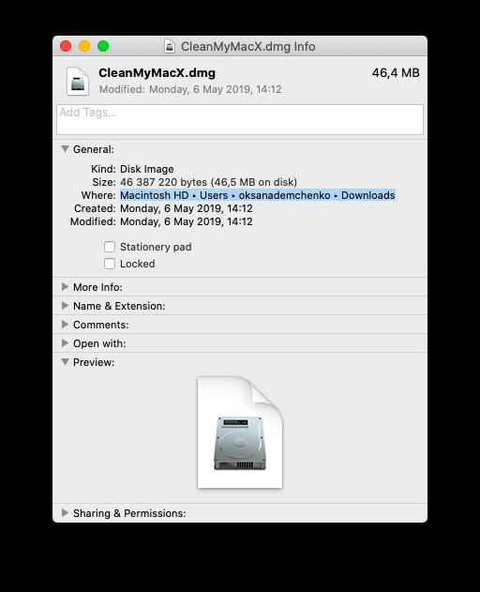

Save the config file, and shut it down!

# Loading the project into DeepLabCut

Open deeplabcut, and go to the “manage project” tab

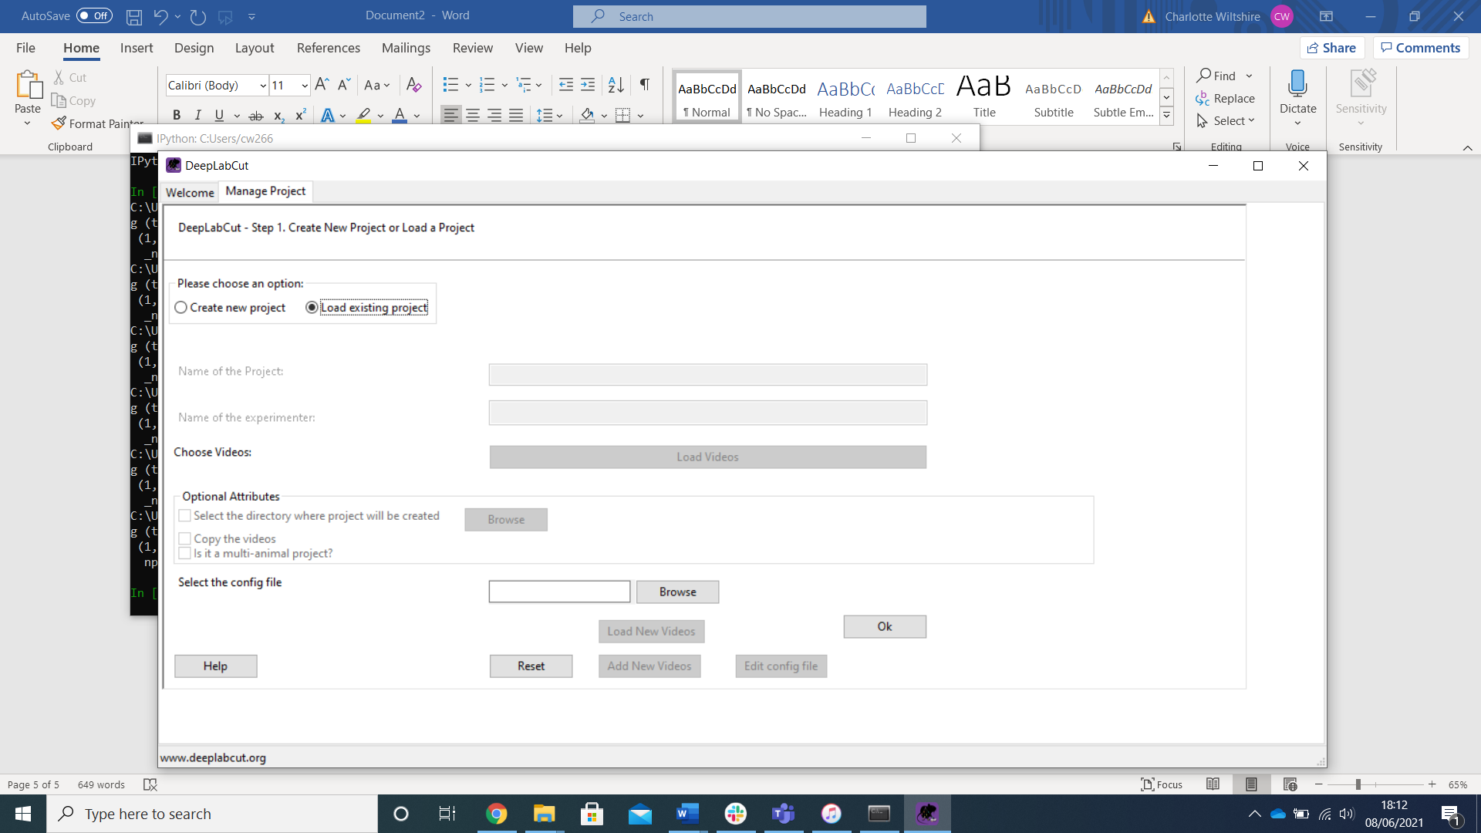

Click browse and select your config file. Then click ok!

Then, go to the “Label frames” tab and click “label frames”

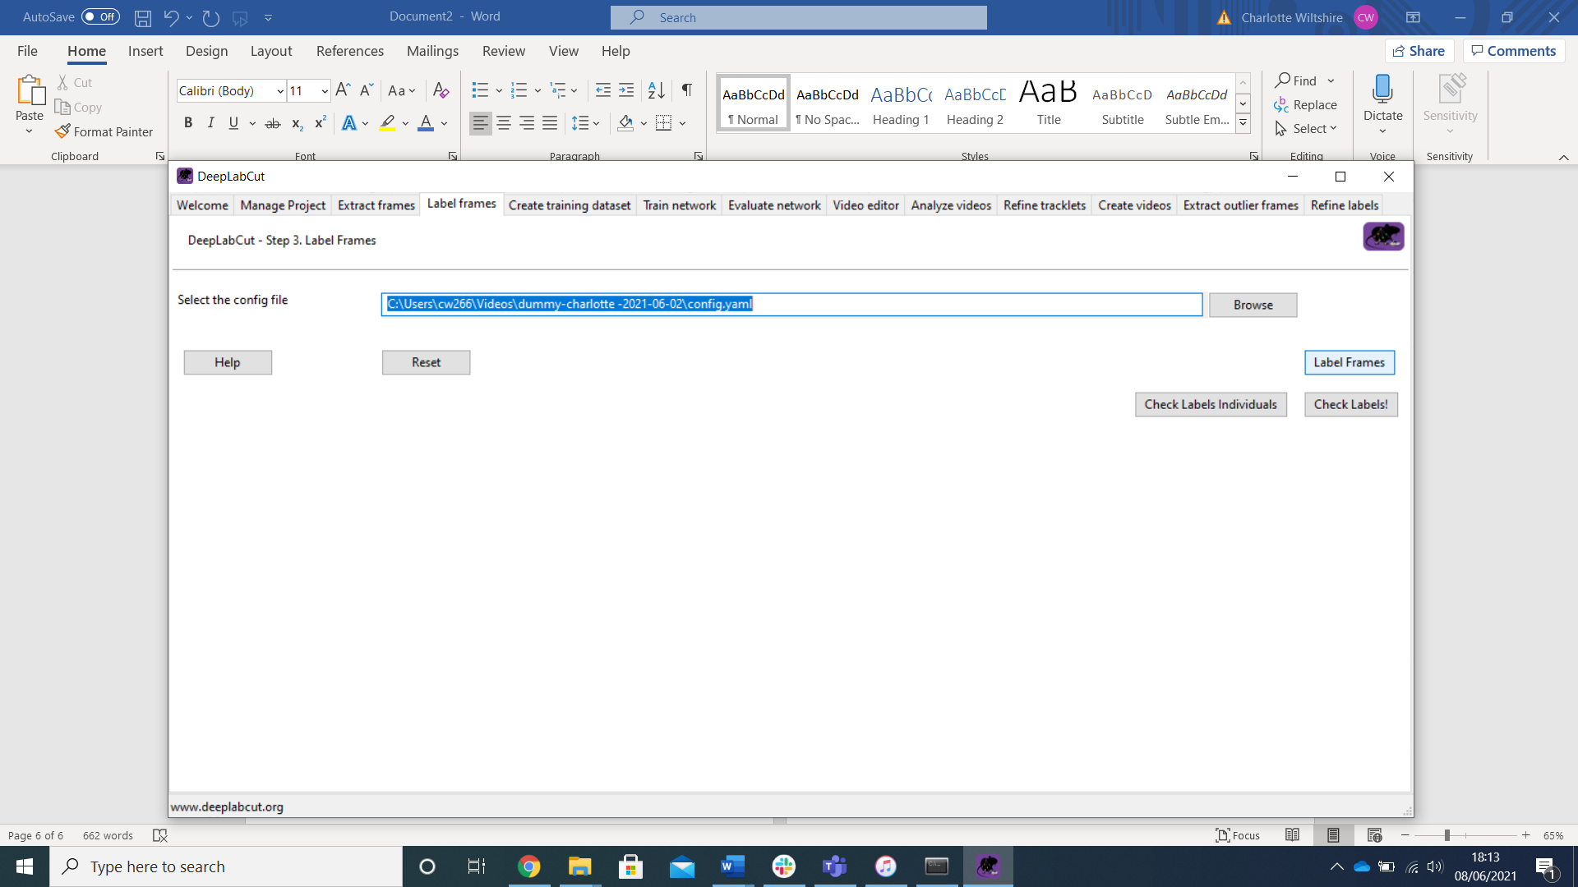

This will bring up a new window. In the bottom left is the button “load frames” click that, and then select the folder you wish to mark.

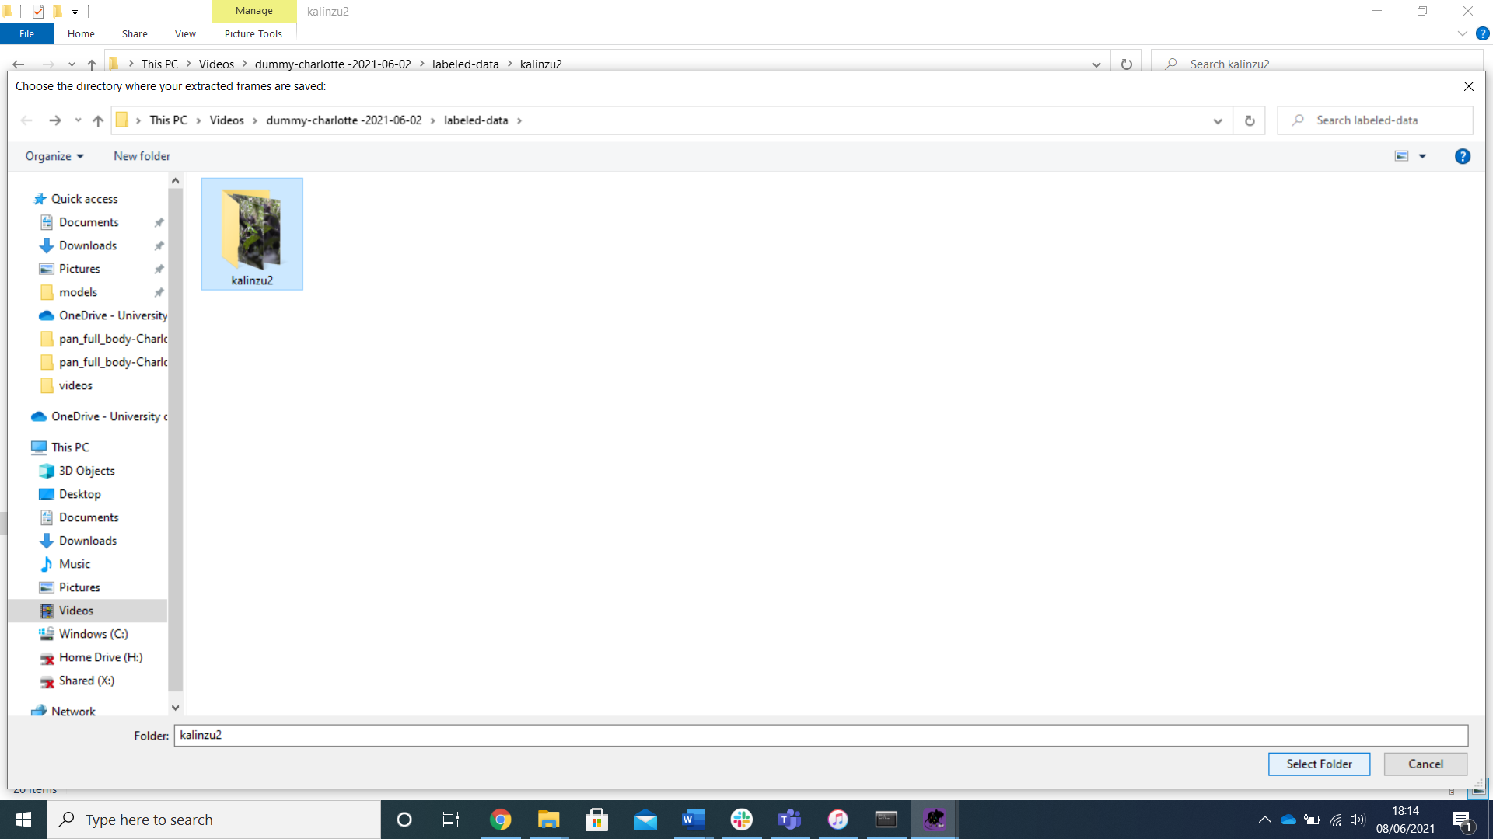

# The labelling GUI explained:

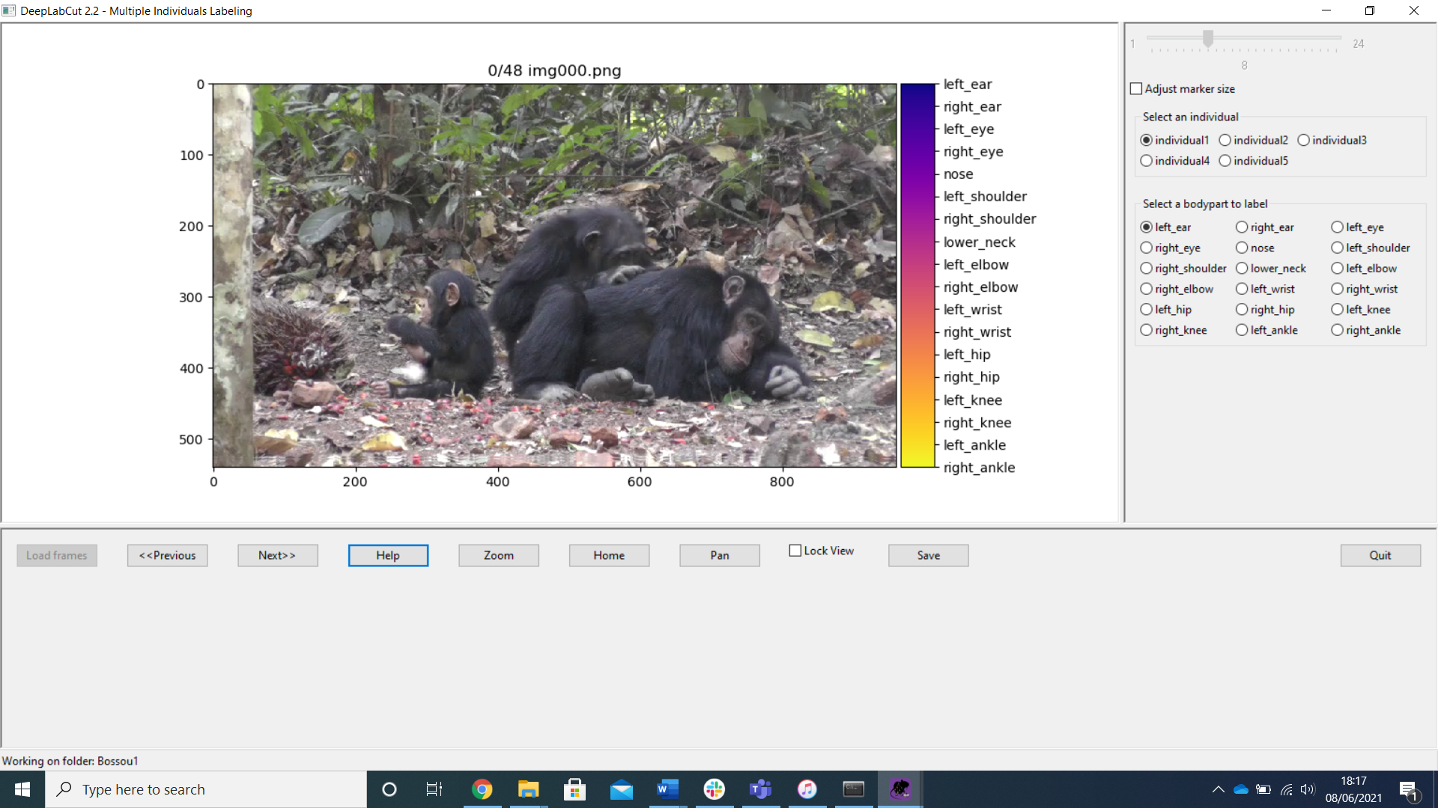

On the right, you can choose which individual you are marking. It doesn’t matter who is individual1/2/3, as long as you are consistent throughout the video.

You can also select which body part to mark. It is important to note which side is left!! It is mirrored!

Click the “**adjust marker size**” And use the scroller at the top to choose the size of your dots (this can be slow, be patient!). This is personal preference. It is important to note that the actual point DeepLabCut is marking is where the arrow points.

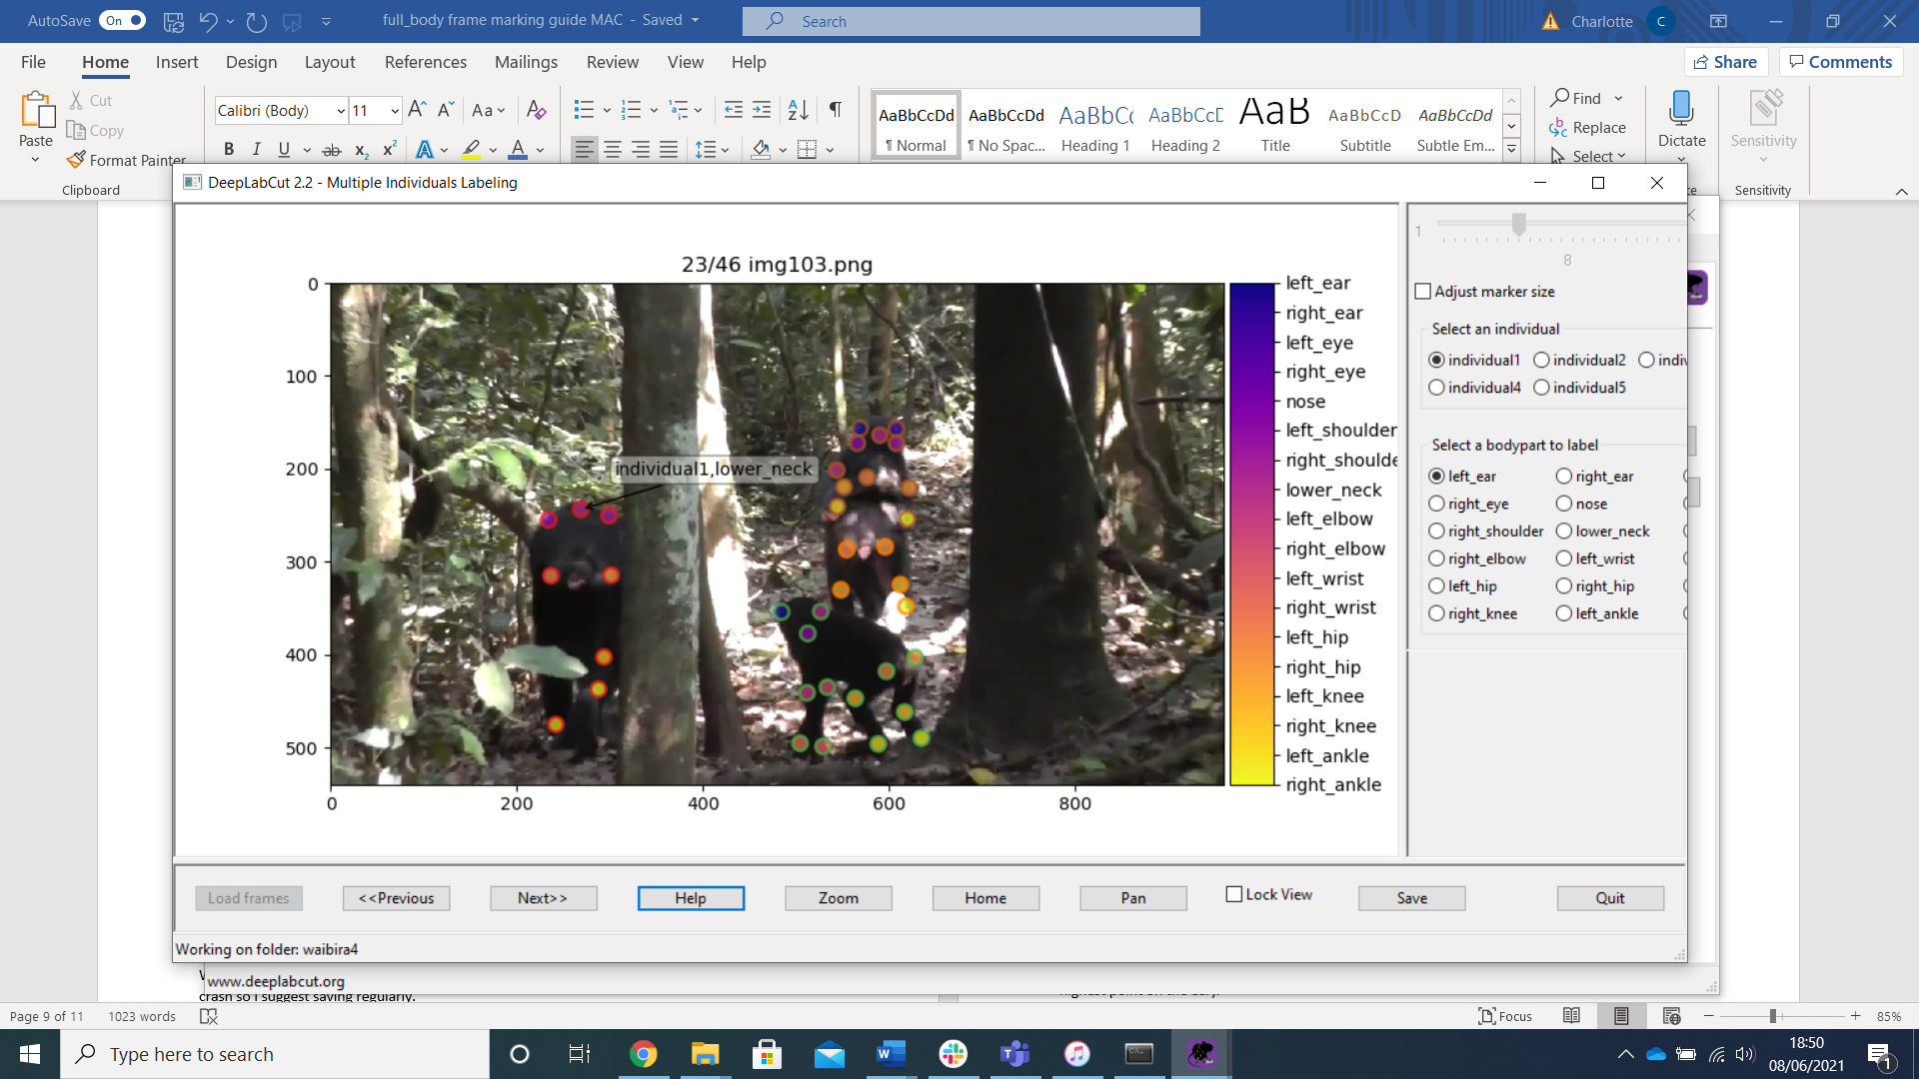

**To mark the point**, right click.  
**To move the point**, left click and drag.   
**To delete the point** press the middle button on your mouse. (If you delete a point and need to replace it, you need to go to a previous frame and back to the one you are marking for DeepLabCut to allow you to mark it again, just a little bug that they need to fix).

The “**previous**” and “**next**” buttons scroll through the frames.

“**zoom**” lets you zoom into the picture, you will need to use this to be precise! To get out of the zoom, use “pan”

When you have finished marking a frame, click “**save**”. You can save at any point. DeepLabCut does crash so I suggest saving regularly.

When you have finished the video (you can’t click next anymore), save and then **quit**! You can also quit part-way through marking a video. Make sure you save, and then quit. When you want to come back to it, just use the “next” button to get back to the next frame that needs marking.

# Marking protocols and examples:

We are marking 18 body parts for this project.   
The most important thing to remember is that the left and right is mirrored!  
Please see below:

**L**

**R**

right_ear

nose



Left_eye

Left_ear

Right_eye

Lower_neck

right_shoulder

Left_shoulder

right_elbow

right_wrist

Left_wrist

right_ankle

right_knee

right_hip

Left_ankle

Left_knee

Left_hip

Left_elbow

The aim is to mark the central point on the joint (with the exception of the ears, please mark the highest point on the ear).   
Hips: These are probably the hardest to mark. You can mark these from the front, back or side. If marking from the front, be sure the belly is not hiding the hip. From the front, I tend to mark if I can see the crevice where the inner thigh meets the body.   
Lower neck: This can be marked from the back and sometimes the side. The central point between the shoulders where the neck begins.

You will have 25 frames per video to mark.   
Save after every frame! Deeplabcut crashes a lot!

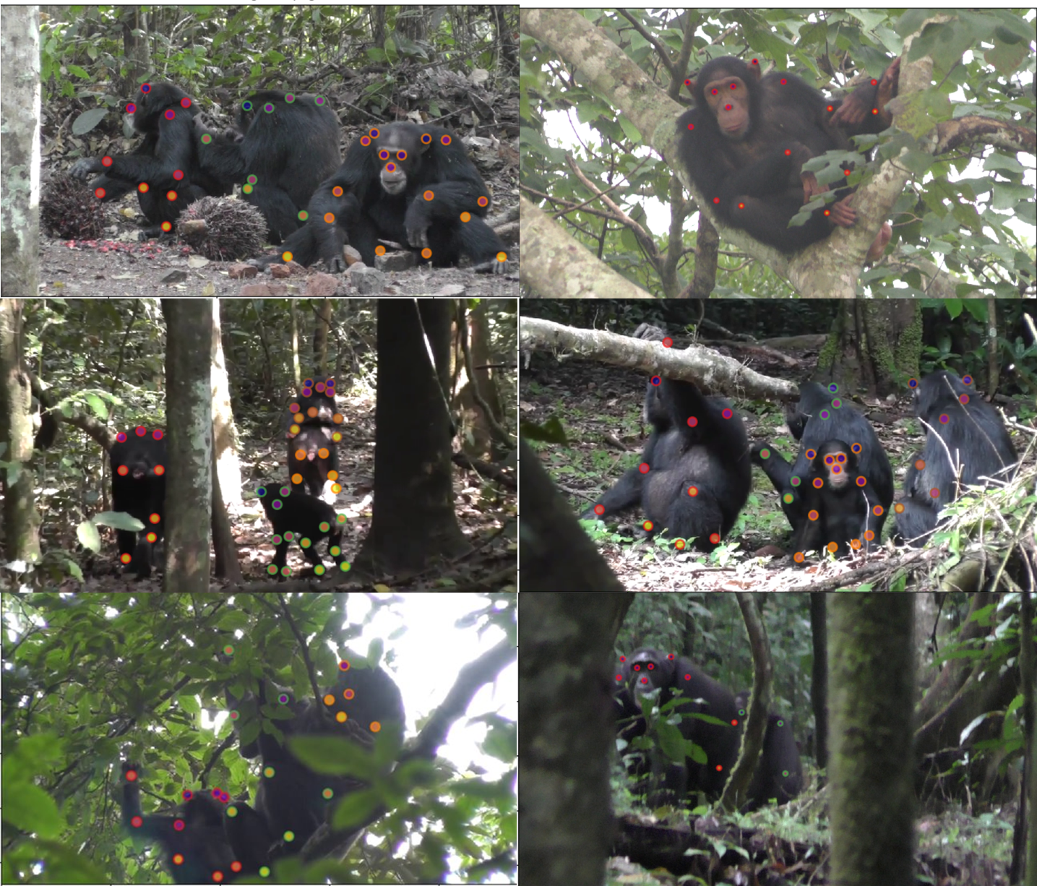

For more examples, please see the “full body chimp examples marking” powerpoint. Also feel free to send frames to me if you are unsure!

# Filling in the Google Sheet:

So we can keep track of what videos have been used in the model, who marked them and when, we have a shared google excel sheet: “full_body_model_data”.  
<https://docs.google.com/spreadsheets/d/1QxYPK69G0jxP7o3NGfQXKpqx37CW97Am/edit?usp=sharing&ouid=117231527259626347382&rtpof=true&sd=true>

On sheet 2 of this file, please fill in the “date marked” and “marker” columns against the videos you have marked (one of the “source video” names should match with your video name).

# Checking your marking

Please send screenshots to Charlotte for feedback once you have marked 10 frames.   
After this, please send 10 random screenshots every 50 frames to be checked.

# Sharing your labelled data with us

When you have finished marking all videos in your dataset , please create a folder within our shared one drive folder where the project was shared with you. Call the folder “marked frames by [your name]”. Within your new folder, please upload the “labelled-data” folder from your computer onto onedrive.